**Document 02 – Sprint 1 Plan**

This document is contained in your GitHub repository in a folder named *docs*.

|  |  |  |  |  |
| --- | --- | --- | --- | --- |
| |  |  | | --- | --- | | Group | 1 | | Group Member Names |  |
|  | |  |  | | --- | --- | | 1. | Carson Davis | | 2. | Johnnie Oldfield | | |  |  | | --- | --- | | 3. | Sean Northcutt | | 4. | Andy Russell | |
|  |  |  |

1. **Actors**

|  |
| --- |
| **Instructions**  Sections 1,2, and 3 are all related.  You will develop at least 10 use cases (more is fine). These should be the most important ones. In a later section, you will rank these on priority.  You should brain storm who the actors are and what they want to accomplish. For example: (1) a customer wants to book a flight, (2) a customer wants to book a flight with companions. (3) the airline wants to know how much revenue is generated from a flight.  **Deliverable**  Provide a numbered list of the Actors you have modelled and a brief description of each. |

|  |  |  |
| --- | --- | --- |
|  | **Actor** | **Description** |
| 1. | Doctor | Prescribe medicine, diagnosis |
| 2. | Patient | Calls receptionists for appointments, receives treatment/medicine |
| 3. | Receptionist | Makes appointments |
| 4. | Nurse | Assists doctor |

1. **Use Case Diagram(s)**

|  |
| --- |
| **Deliverable**  Provide a neat, legible, properly sized UML use case diagram(s). Accompany these with any discussion that is necessary. It is acceptable to move the diagram(s) to the next page if needed for it to be displayed optimally. |

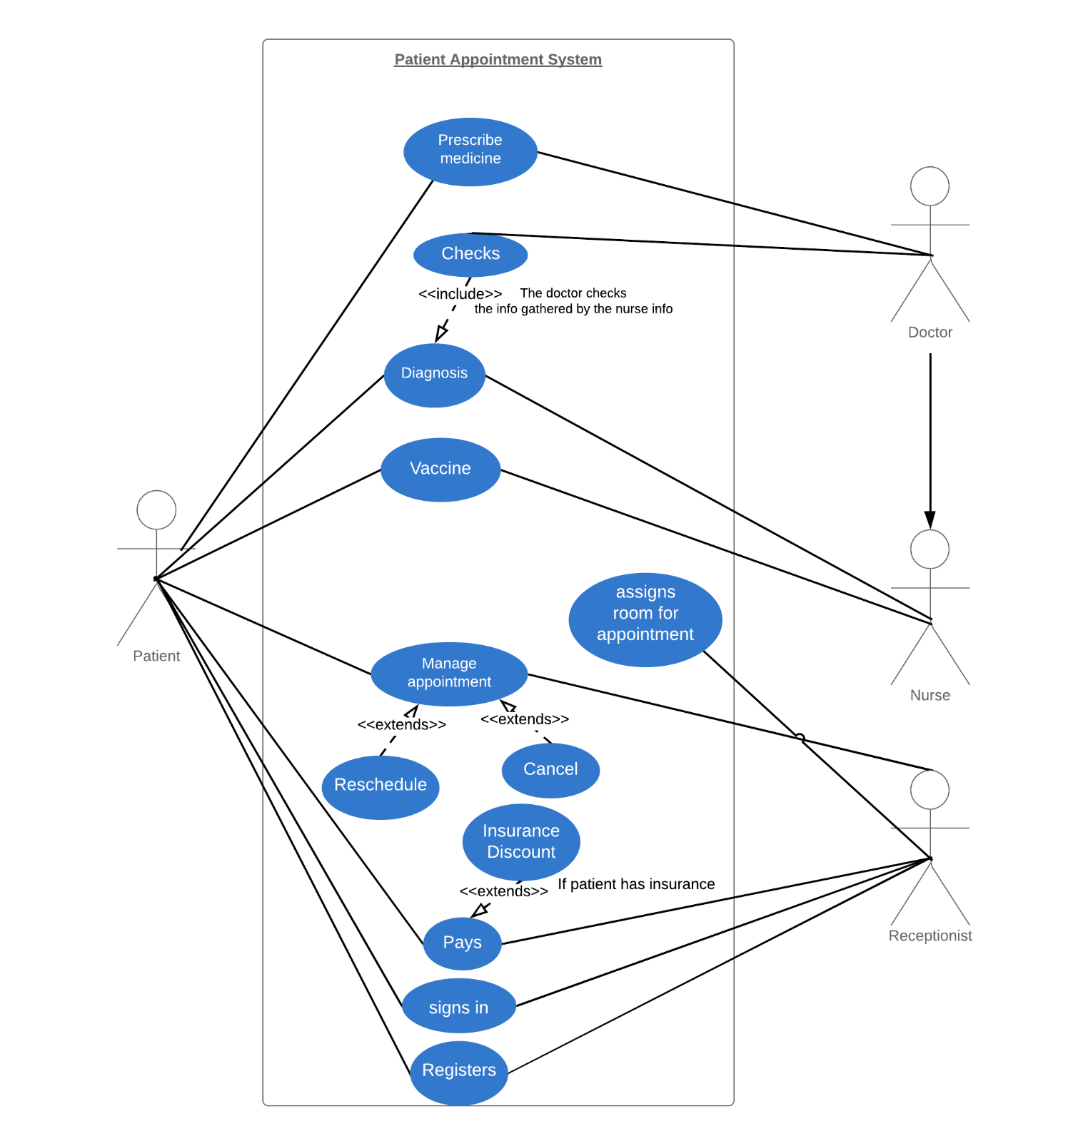

1. **Use Case Descriptions**

|  |
| --- |
| **Deliverable**  Provide a numbered list of use cases ordered by their priority and a brief description of each. |

|  |  |  |
| --- | --- | --- |
| **Priority** | **Use Case Title** | **Description** |
| 1. | Prescription | Doctor prescribes drugs to Patient |
| 2. | Appointment | Patient sets up Appointment with Receptionist |
| 3. | Vaccines | Nurse administers shots |
| 4. | Assign Room | Receptionist assigns a Room to an Appointment |
| 5. | Diagnosis | Nurse gathers Patient information. |
| 6. | Patient Reschedule | Patient can reschedule/cancel Appointment |
| 7. | Receptionist Reschedule | Receptionist can reschedule/cancel an Appointment |
| 8. | Payment | Patient pays Receptionists |
| 9. | Insurance | Receptionist gathers insurance Patient |
| 10. | Diagnosis Check | Doctor checks information gathered by Nurse |
| 11. | Sign in | Patient signs in with Receptionist |
| 12. | Registration | Receptionist registers Patient |

1. **Class Diagram**

|  |
| --- |
| **Deliverable**  Consider the first 5 (more is fine) or so use cases and develop a neat, legible, properly sized UML class diagram(s) showing your initial design. Classes should show state and behavior. It is not important to capture every detail. Every time you look at your document, you will see new things you didn’t think of before: a required instance variable, a parameter for a method, a missing method, a method in the wrong class, a new class, etc. The important point is to establish a starting point for the design. |

